**ABSTRACT**

The "Doctor Appointment System (DAS)" is a sophisticated online platform poised to revolutionize healthcare appointment scheduling and management. Developed to bridge the gap between traditional appointment booking methods and modern technological advancements, DAS provides a seamless and interactive environment for patients, healthcare providers, and administrative staff. The system comprises four main modules: Patient, Doctor, Administrative, and Data Management, each tailored to meet specific needs within the healthcare industry.

The Patient Module offers a user-friendly interface for patients to schedule appointments, access healthcare providers' profiles, and receive appointment reminders. With real-time availability updates and personalized features, patients can easily manage their healthcare schedules and engage more actively with medical services.

The Doctor Module empowers healthcare providers with tools to manage appointment schedules, access patient records, and communicate securely with patients. Through the platform, doctors can optimize resource utilization, deliver personalized care, and enhance patient-provider relationships.

The Administrative Module provides administrative staff with tools to manage user accounts, system settings, and backups. Administrators can configure system settings, monitor performance, and ensure compliance with regulatory requirements, streamlining administrative processes within healthcare facilities.

The Data Management Module ensures effective data administration, including patient records, appointment information, and system logs. Utilizing robust data management practices, the system securely stores and manages data, ensuring reliability and data integrity.

Overall, the Doctor Appointment System (DAS) represents a significant advancement in healthcare appointment scheduling, offering a comprehensive solution to improve patient experiences, streamline administrative processes, and enhance overall efficiency in healthcare delivery. By leveraging technology and innovative design principles, DAS aims to transform the healthcare appointment scheduling experience for patients and healthcare providers worldwide.

**ACKNOWLEDGEMENT**

We express our heartfelt gratitude to **Dr S Thangavelu,** our esteemed Chairman, for providing a wonderful platform for us to expand our horizons, instill new ideas, and implement technological advancements in the real world

Our heartfelt appreciation to our passionate Secretary, **Mr T Dheepan,** for stressing the value of placing our project’s research into motion so that it can be a successful solution to every current problem

Our sincere gratitude to our dynamic Secretary, **Mr T Sheelan,** for overseeing the facilities and creating a conducive work environment for us to execute the programme.

We owe it to our  beloved Principal, **Dr A R Ravi Kumar,** to express our gratitude for his  unwavering help in instilling in us the values of ethics and morals in our daily lives.

A big salute to our vibrant Head of the Department, **Dr S Prakash,** for imbibing the scope of project  and systematic procedure in execution. We express our genuine thanks for encouraging us throughout the project period to complete it successfully.

We are grateful to our mentor, **Dr S Prakash,** for leading us through the construction of this project, and for his ongoing support in ensuring that our project process went smoothly, as well as helping us realize our potential.

We are grateful to our parents, teachers and friends for their unwavering love, perseverance, and keen interest in motivating us at all times with their encouraging words. Finally, we express our heartfelt gratitude to the Almighty for all of his efforts that we execute the right project at the right time

**Shanjai R**

**Muhil R**

**Nathish Surya M**

**CHAPTER - 3. INTRODUCTION**

In contemporary society, the healthcare landscape stands as a critical pillar of public health, wellness, and societal well-being, shaping the physical, mental, and social dimensions of individuals' lives. However, amidst the evolving demands, demographics, and technological advancements in healthcare, traditional appointment scheduling systems face increasing scrutiny regarding their ability to meet the diverse and dynamic needs of patients, healthcare providers, and administrative staff. Recognizing the imperative for innovation in healthcare delivery, this paper proposes the "Doctor Appointment System (DAS)"—a transformative platform designed to revolutionize appointment scheduling and management by prioritizing efficiency, accessibility, and patient-centered care.

**The Evolving Landscape of Healthcare:**

The dawn of the digital age has ushered in a new era of healthcare delivery, characterized by advancements in telemedicine, electronic health records, and patient engagement technologies. As consumers of healthcare services become more digitally savvy and accustomed to on-demand access to information and services, traditional healthcare delivery models face challenges in meeting patient expectations for convenience, efficiency, and personalized care.

Furthermore, demographic shifts, such as an aging population and increasing chronic disease burden, underscore the importance of streamlining healthcare processes, optimizing resource utilization, and enhancing patient experiences. In this context, traditional appointment scheduling systems often struggle to keep pace with the evolving needs and expectations of patients and healthcare providers alike.

**Challenges of Traditional Appointment Scheduling:**

Traditional appointment scheduling systems, characterized by manual processes, long wait times, and limited accessibility, present several inherent challenges that hinder effective healthcare delivery and patient satisfaction. These challenges include:

Long Waiting Times: Patients often experience extended wait times for appointments, leading to frustration, dissatisfaction, and delayed access to care.

Inefficient Resource Utilization: Healthcare providers struggle to optimize appointment schedules, leading to underutilization of resources, inefficiencies in care delivery, and increased costs.

Limited Accessibility: Traditional appointment scheduling systems may lack accessibility features, such as online booking options or multilingual support, limiting access for patients with diverse needs and preferences.

Poor Communication Channels: Ineffective communication channels between patients and healthcare providers contribute to misunderstandings, missed appointments, and suboptimal patient-provider relationships.

**The Promise of the Doctor Appointment System (DAS):**

Amidst these challenges, the Doctor Appointment System (DAS) emerges as a promising solution to revolutionize healthcare appointment scheduling and management. Designed to prioritize efficiency, accessibility, and patient-centered care, DAS aims to streamline the appointment booking process, enhance patient experiences, and optimize resource utilization within healthcare facilities.

**Key Features of the Doctor Appointment System (DAS):**

The Doctor Appointment System (DAS) offers several key features designed to address the challenges of traditional appointment scheduling systems and enhance the overall healthcare experience. These features include:

Online Appointment Booking: Patients can easily schedule appointments online, reducing wait times and improving access to care.

Real-Time Availability Updates: Healthcare providers can update their availability in real-time, ensuring accurate appointment scheduling and efficient resource allocation.

Secure Communication Channels: DAS provides secure communication channels for patients and healthcare providers to communicate, exchange information, and address concerns.

Accessibility Features: DAS offers accessibility features such as multilingual support and online booking options, ensuring equitable access to healthcare services for all patients.

In the subsequent sections of this paper, we will delve into the theoretical underpinnings, practical implementation strategies, and potential impact of the Doctor Appointment System (DAS) on healthcare delivery, patient outcomes, and organizational efficiency.

**CHAPTER - 4. PROBLEM STATEMENT**

In the endeavor to modernize healthcare appointment scheduling through the Doctor Appointment System (DAS), several challenges and opportunities arise regarding its implementation and optimization. While DAS promises to streamline the appointment booking process and enhance patient experiences, ensuring its seamless integration into existing healthcare workflows and addressing potential barriers to adoption represent critical considerations. Therefore, the problem statement outlined in this chapter aims to investigate how to effectively implement and optimize the Doctor Appointment System (DAS) to improve healthcare access, efficiency, and patient satisfaction.

**Navigating Integration Challenges:**

The successful integration of the Doctor Appointment System (DAS) into healthcare facilities requires overcoming various integration challenges, including technical compatibility with existing systems, data security and privacy concerns, and resistance to change among healthcare staff. Additionally, ensuring interoperability with electronic health records (EHRs) and other healthcare information systems poses a significant challenge in achieving seamless data exchange and continuity of care.

**Enhancing Patient Engagement and Access:**

While DAS offers the potential to enhance patient engagement and access to healthcare services, ensuring equitable access for all patients, including those with limited digital literacy or internet access, remains a critical consideration. Moreover, addressing disparities in healthcare access among underserved populations, including rural communities and marginalized groups, presents a significant challenge in achieving healthcare equity through DAS.

**Optimizing Resource Utilization and Efficiency:**

One of the primary goals of DAS is to optimize resource utilization and efficiency within healthcare facilities by reducing wait times, minimizing appointment no-shows, and improving provider productivity. However, achieving these objectives requires careful coordination and alignment with existing scheduling practices, staffing levels, and facility capacity constraints. Additionally, addressing concerns regarding overbooking, appointment bottlenecks, and resource allocation algorithms represents a critical challenge in maximizing the efficiency gains offered by DAS.

**Ensuring Data Security and Privacy:**

As DAS relies on the collection and storage of sensitive patient data, ensuring robust data security and privacy safeguards is paramount to maintaining patient trust and compliance with regulatory requirements. Addressing concerns related to data breaches, unauthorized access, and patient confidentiality poses a significant challenge in implementing and optimizing DAS within healthcare settings.

By exploring these challenges and opportunities, this chapter aims to identify practical strategies, best practices, and recommendations for effectively implementing and optimizing the Doctor Appointment System (DAS) in healthcare settings. Through a comprehensive examination of these key considerations, we seek to enhance healthcare access, efficiency, and patient satisfaction, ultimately advancing the delivery of quality care in diverse healthcare environments.

**CHAPTER - 5. EXISTING SOLUTION**

In the realm of doctor appointment scheduling and management, various existing solutions and practices address the challenges encountered in healthcare facilities. Understanding these solutions is crucial for informing the development of the Doctor Appointment System (DAS) and identifying areas for improvement. Some of the existing solutions in the field of appointment scheduling and patient management include:

**1. Manual Appointment Booking Systems:**

Many healthcare facilities still rely on traditional manual appointment booking systems, where patients schedule appointments via phone calls or in-person visits to the clinic. While this approach allows for direct patient-provider interaction and personalized assistance, it can be time-consuming and inefficient. Patients may experience long wait times on the phone, and staff must manually input appointment details into scheduling systems, increasing the risk of errors and inconsistencies.

**2. Electronic Health Record (EHR) Systems:**

Electronic Health Record (EHR) systems are widely used in healthcare settings to store patient medical records, including appointment schedules. While EHR systems offer benefits such as centralized data storage and accessibility, they may lack dedicated features for appointment scheduling and management. Integrating appointment scheduling functionality into existing EHR systems can be complex and may require additional customization or third-party solutions.

**3. Online Appointment Booking Platforms:**

Many healthcare providers offer online appointment booking platforms that allow patients to schedule appointments via websites or mobile applications. These platforms offer convenience and flexibility, enabling patients to book appointments outside of regular business hours and from any location with internet access. However, online appointment booking platforms may lack integration with other healthcare systems, leading to disjointed workflows and communication gaps between patients and providers.

**4. Third-Party Appointment Scheduling Services:**

Some healthcare facilities opt to outsource appointment scheduling to third-party services or call centers. These services handle appointment booking tasks on behalf of healthcare providers, freeing up staff time and resources. However, relying on third-party services can introduce additional costs and dependencies, and may not always align with the provider's scheduling preferences or patient needs.

**5. Patient Reminder Systems:**

Patient reminder systems, such as automated phone calls, text messages, or email reminders, help reduce appointment no-show rates by sending timely reminders to patients before their scheduled appointments. These systems improve appointment attendance and optimize resource utilization by reducing wasted appointment slots. However, reminder systems may not be fully integrated with appointment scheduling systems, leading to manual data synchronization and potential communication delays.

In response to the limitations of existing appointment scheduling solutions, the Doctor Appointment System (DAS) aims to provide a comprehensive and user-friendly platform for efficient appointment booking and management. By leveraging technology and incorporating features tailored to the needs of healthcare providers and patients, DAS seeks to streamline appointment scheduling workflows, enhance patient experiences, and improve overall healthcare delivery. Through an analysis of existing solutions and best practices, DAS can identify opportunities for innovation and optimization, ultimately leading to a more effective and accessible appointment scheduling system in healthcare settings.

**CHAPTER - 6. LITERATURE SURVEY**

In the realm of doctor appointment scheduling and management, various studies and research provide insights into the challenges, trends, and best practices shaping the field. This literature survey explores key areas of research and developments related to appointment scheduling, patient management, and healthcare technology to inform the development of the Doctor Appointment System (DAS).

**1. Appointment Scheduling and Patient Access:**

1.1. Patient-Centered Appointment Scheduling: Research by Murray et al. (2009) and Mehrotra et al. (2008) emphasizes the importance of patient-centered approaches to appointment scheduling. Patient preferences, accessibility, and convenience play crucial roles in optimizing scheduling systems to meet patient needs and improve healthcare access.

1.2. Impact of Appointment Wait Times: Studies by Bae and Bae (2019) and Rajkomar et al. (2017) highlight the negative effects of long appointment wait times on patient satisfaction and healthcare outcomes. Efficient appointment scheduling systems can help reduce wait times and enhance patient experiences.

**2. Technology and Healthcare Innovation:**

2.1. Adoption of Digital Health Technologies: The adoption of digital health technologies, including appointment scheduling platforms, has been on the rise. Research by Adler-Milstein et al. (2017) and Greenhalgh et al. (2016) explores the impact of technology on healthcare delivery, patient engagement, and workflow optimization.

2.2. Telemedicine and Remote Consultations: Telemedicine platforms, as studied by Hollander and Carr (2020) and Wosik et al. (2020), have gained prominence, particularly in light of the COVID-19 pandemic. These platforms enable remote consultations and virtual appointments, offering convenience and accessibility for patients.

**3. Patient Engagement and Communication:**

3.1. Importance of Patient Communication: Effective communication between patients and healthcare providers is essential for appointment scheduling and care coordination. Research by Street et al. (2009) and Barry et al. (2012) underscores the significance of clear communication, shared decision-making, and patient engagement in healthcare delivery.

3.2. Role of Patient Portals: Patient portals, as discussed by Irizarry et al. (2015) and Ammenwerth et al. (2012), facilitate communication, appointment scheduling, and access to medical records. Integrating appointment scheduling functionality into patient portals can enhance patient engagement and self-management.

**4. Healthcare Access and Equity:**

4.1. Addressing Healthcare Disparities: Disparities in healthcare access and utilization persist among underserved populations. Research by Shi et al. (2018) and Artiga et al. (2018) examines strategies for addressing healthcare disparities and improving access to care through innovative scheduling approaches and community-based interventions.

4.2. Digital Health Equity: Ensuring equitable access to digital health technologies is crucial for addressing disparities in healthcare access. Studies by Pew Research Center (2021) and Kontos et al. (2014) explore factors influencing digital health adoption and strategies for promoting digital health equity among diverse populations.

**5. Healthcare Workflow Optimization:**

5.1. Workflow Efficiency and Patient Flow: Optimizing healthcare workflows and patient flow is essential for maximizing resource utilization and improving quality of care. Research by Gittell et al. (2010) and Powell et al. (2015) examines strategies for streamlining appointment scheduling processes and enhancing operational efficiency in healthcare settings.

5.2. Integration of Healthcare Systems: Seamless integration of appointment scheduling systems with electronic health records (EHRs), billing systems, and other healthcare technologies is critical for ensuring continuity of care and data interoperability. Studies by Hersh et al. (2015) and Sittig and Singh (2016) explore challenges and opportunities in healthcare system integration.

The literature survey highlights the multifaceted nature of appointment scheduling and patient management in healthcare, encompassing patient-centered approaches, technology adoption, communication strategies, healthcare equity, and workflow optimization. By synthesizing insights from existing research, DAS can leverage best practices and innovative solutions to develop a robust appointment scheduling system that meets the needs of patients, providers, and healthcare organizations. Through effective utilization of technology and patient engagement strategies, DAS aims to enhance healthcare access, improve patient experiences, and optimize appointment scheduling processes in healthcare settings.

**CHAPTER - 7. ABSTRACT**

The Doctor Appointment System (DAS) is a pioneering digital platform designed to streamline and optimize the process of scheduling and managing doctor appointments. With a focus on enhancing patient access, improving communication, and optimizing healthcare workflows, DAS offers a comprehensive solution tailored to the needs of patients, healthcare providers, and healthcare organizations.

**Patient-Centric Features:**

DAS prioritizes patient convenience and accessibility with its intuitive and user-friendly interface. Patients can easily search for available appointment slots, select preferred healthcare providers, and book appointments in real-time. The platform offers flexibility, allowing patients to schedule appointments from any device, whether desktop or mobile, and receive instant confirmation.

**Efficient Appointment Management:**

Healthcare providers benefit from DAS's robust appointment management tools, which streamline scheduling processes and optimize resource utilization. Providers can view their appointment schedules, manage patient bookings, and update availability in real-time. Automated reminders and notifications reduce no-show rates and improve patient adherence to appointments.

**Seamless Communication:**

DAS facilitates seamless communication between patients and healthcare providers, enhancing patient engagement and care coordination. Patients can securely message their providers, share relevant medical information, and receive timely updates regarding their appointments. Providers can respond to patient inquiries, provide instructions, and deliver personalized care recommendations through the platform.

**Integration with Healthcare Ecosystem:**

DAS seamlessly integrates with existing healthcare systems, including electronic health records (EHRs), practice management software, and billing platforms. This integration ensures data interoperability, streamlines administrative tasks, and enhances continuity of care across healthcare settings. Providers can access patient medical records, review past appointments, and track treatment plans within the DAS ecosystem.

**Scalability and Customization:**

The technical architecture of DAS is built on scalable and adaptable technologies, including HTML, CSS, JavaScript, PHP, and MySQL. This architecture ensures flexibility, allowing DAS to accommodate the unique needs and preferences of different healthcare organizations. Customization options enable providers to tailor the platform to their specific workflows, branding, and patient populations.

**Revenue Generation Opportunities:**

DAS offers revenue generation opportunities through subscription-based licensing models, premium features, and strategic partnerships. Healthcare organizations can leverage DAS to optimize appointment scheduling, improve patient engagement, and enhance operational efficiency, resulting in cost savings and revenue growth.

In summary, the Doctor Appointment System represents a transformative solution that revolutionizes appointment scheduling and management in healthcare. By leveraging technology, enhancing communication, and prioritizing patient-centric care, DAS aims to improve access to care, optimize healthcare workflows, and elevate the patient experience. As healthcare continues to evolve, DAS remains at the forefront, adapting to emerging trends and innovations to meet the evolving needs of patients and providers alike.

**CHAPTER - 8. PROPOSED SOLUTION**

In addressing the challenges and opportunities presented by the Doctor Appointment System (DAS), it is essential to propose comprehensive solutions that enhance patient access, streamline healthcare workflows, and improve communication between patients and healthcare providers. By leveraging technology, implementing patient-centric features, and optimizing system integration, DAS can revolutionize the healthcare experience and facilitate better health outcomes for patients. This chapter outlines proposed solutions for optimizing DAS, focusing on key areas such as patient engagement, appointment management, communication, and system interoperability.

**Enhancing Patient Access and Convenience:**

One of the primary goals of DAS is to enhance patient access to healthcare services by providing a user-friendly and intuitive platform for scheduling appointments. To achieve this, DAS should prioritize mobile responsiveness, ensuring that patients can easily access the system from any device, including smartphones and tablets. Additionally, DAS should offer multiple appointment scheduling options, such as online booking, mobile app integration, and telephone assistance, to accommodate diverse patient preferences and needs. By enhancing patient access and convenience, DAS can improve healthcare accessibility and promote timely access to care for patients.

**Streamlining Appointment Management:**

Efficient appointment management is essential for optimizing healthcare workflows and ensuring optimal resource utilization. DAS should incorporate features such as real-time appointment scheduling, automated reminders, and appointment confirmation notifications to streamline the appointment booking process and reduce no-show rates. Moreover, DAS should offer flexible scheduling options, allowing patients to book appointments based on their availability and preferences. By implementing these features, DAS can optimize appointment management, reduce administrative burden on healthcare providers, and improve overall efficiency in healthcare delivery.

**Facilitating Seamless Communication:**

Effective communication between patients and healthcare providers is crucial for delivering high-quality care and fostering patient engagement. DAS should incorporate secure messaging capabilities, allowing patients to communicate with their providers, ask questions, and receive timely updates regarding their appointments and treatment plans. Additionally, DAS should facilitate information sharing between patients and providers, enabling patients to upload relevant medical records, lab results, and medication lists securely. By facilitating seamless communication, DAS can enhance patient-provider relationships, improve care coordination, and promote patient empowerment and involvement in their healthcare journey.

**Ensuring System Integration and Interoperability:**

System integration and interoperability are essential for ensuring that DAS seamlessly integrates with existing healthcare systems, including electronic health records (EHRs), practice management software, and billing platforms. DAS should support standard healthcare data exchange protocols, such as HL7 and FHIR, to facilitate seamless data sharing and interoperability with other healthcare systems. Moreover, DAS should offer robust APIs and data integration capabilities, allowing healthcare organizations to integrate DAS with their existing IT infrastructure seamlessly. By ensuring system integration and interoperability, DAS can enhance data accuracy, streamline administrative processes, and improve continuity of care across healthcare settings.

In conclusion, the proposed solutions outlined in this chapter offer practical strategies for optimizing the Doctor Appointment System (DAS) and enhancing the healthcare experience for patients and providers. By prioritizing patient access, streamlining appointment management, facilitating seamless communication, and ensuring system integration, DAS can revolutionize the healthcare delivery process and improve patient outcomes. As healthcare continues to evolve in the digital age, it is essential to embrace innovative solutions that prioritize patient-centered care, enhance communication, and promote efficiency in healthcare delivery. Through the implementation of these proposed solutions, DAS can realize its full potential as a transformative tool for improving access to care and enhancing patient engagement in healthcare.

**CHAPTER - 9. EXECUTIVE SUMMARY**

The Doctor Appointment System (DAS) is designed to optimize the healthcare experience for both patients and providers by improving access, streamlining appointment management, enhancing communication, and ensuring system integration. This executive summary highlights key components, challenges, and proposed solutions for optimizing DAS to achieve these goals.

**Enhancing Patient Access and Convenience:**

DAS aims to improve patient access to healthcare services by offering user-friendly interfaces, mobile responsiveness, and multiple appointment scheduling options. Patients can easily book appointments online, through mobile apps, or via telephone, ensuring timely access to care and promoting convenience.

**Streamlining Appointment Management:**

Efficient appointment management is facilitated through real-time scheduling, automated reminders, and flexible booking options. DAS reduces administrative burden, optimizes resource utilization, and minimizes no-show rates, ensuring efficient use of healthcare resources and enhancing patient satisfaction.

**Facilitating Seamless Communication:**

Effective communication between patients and providers is essential for delivering high-quality care. DAS incorporates secure messaging capabilities, information sharing functionalities, and patient-provider communication tools to foster seamless communication and enhance patient engagement.

In conclusion, the proposed solutions outlined in this executive summary offer practical strategies for optimizing the Doctor Appointment System (DAS) and improving the healthcare experience for patients and providers. By prioritizing patient access, streamlining appointment management, facilitating seamless communication, and ensuring system integration, DAS can revolutionize the healthcare delivery process and promote better health outcomes for all stakeholders.

**CHAPTER - 10. BUSINESS VIABILITY**

The Doctor Appointment System (DAS) represents not only a significant improvement in healthcare service delivery but also holds substantial potential for business viability and sustainability. This essay explores the economic feasibility, revenue models, scalability, and long-term viability of implementing DAS in healthcare organizations.

**Economic Feasibility:**

The economic feasibility of DAS relies on factors such as initial investment, operational costs, revenue potential, and return on investment. While implementing DAS may require upfront investment in technology infrastructure, software development, and staff training, the potential benefits in terms of improved operational efficiency, reduced administrative burden, and enhanced patient satisfaction can outweigh these costs.

Moreover, DAS offers cost-saving opportunities by optimizing resource utilization, minimizing appointment no-show rates, and streamlining administrative processes. By reducing inefficiencies and improving patient access to care, healthcare organizations can achieve long-term economic viability and financial sustainability with DAS.

**Revenue Models:**

Various revenue models can be explored to monetize DAS and ensure its financial sustainability. These may include subscription-based models, transaction-based models, or hybrid models combining upfront fees with additional revenue streams.

Subscription-based models offer recurring revenue streams, allowing healthcare organizations to charge patients or providers a monthly or annual subscription fee for access to DAS features and services. Transaction-based models involve charging fees for specific services or transactions, such as appointment bookings, telemedicine consultations, or value-added services. Hybrid models combine subscription fees with transactional charges, offering flexibility and customization to meet the diverse needs of healthcare organizations and patients.

**Scalability and Long-Term Viability:**

The scalability of DAS is critical for its long-term viability and growth potential in the healthcare industry. By leveraging cloud-based infrastructure, scalable software architecture, and interoperability standards, DAS can accommodate increasing patient volumes, expand service offerings, and adapt to evolving healthcare needs.

Furthermore, strategic partnerships, collaborations, and expansion into new markets can drive the scalability and market penetration of DAS. Healthcare organizations can leverage DAS to enhance patient engagement, improve health outcomes, and differentiate themselves in a competitive marketplace. Continuous investment in research and development, user feedback, and technological innovation is essential for ensuring the long-term relevance and competitiveness of DAS in the healthcare industry.

In conclusion, DAS holds considerable business viability, driven by its potential to improve operational efficiency, enhance patient access to care, and deliver a superior healthcare experience. By exploring innovative revenue models, prioritizing scalability, and embracing technological advancements, healthcare organizations can capitalize on the economic opportunities presented by DAS and lead the transformation of healthcare delivery in the digital age.

**CHAPTER - 11 SOFTWARE REQUIREMENTS**

1. Web Development Stack:

Choice: HTML, CSS, AngularJS, .NET, SQL Server

Explanation:

HTML, CSS, and AngularJS: AngularJS will handle front-end development, providing a dynamic and responsive user interface.

.NET: .NET will serve as the backend framework, facilitating server-side logic, user authentication, and database interactions.

SQL Server: SQL Server will be utilized as the relational database management system (RDBMS) for efficient storage and retrieval of data.

2. Web Hosting:

Choice: Cloud-Based Hosting Services (e.g., Microsoft Azure, AWS)

Explanation:

Cloud-based hosting services offer scalability, reliability, and cost-effectiveness, ensuring high availability and efficient resource allocation for DAS.

3. Content Management System (CMS):

Choice: Custom CMS Development

Explanation:

- A custom CMS tailored to DAS's specific requirements will provide flexibility and control over content management, user access, and appointment scheduling.

4. Web Framework:

Choice: ASP.NET MVC

Explanation:

ASP.NET MVC is a robust framework for building scalable and maintainable web applications using the Model-View-Controller architectural pattern, aligning with DAS's requirements.

5. Multimedia Integration:

Choice: HTML5 Video and Audio Players

Explanation:

- HTML5's built-in video and audio players will ensure seamless integration of multimedia content within DAS, providing an enhanced user experience.

6. Security Framework:

Choice: Secure Sockets Layer (SSL) and Encryption Protocols

Explanation:

- SSL and encryption protocols will ensure data security during transmission and storage, safeguarding sensitive patient information.

7. Accessibility Features:

Choice: Web Content Accessibility Guidelines (WCAG) Compliance

Explanation:

- WCAG compliance will ensure DAS's accessibility for users with disabilities, promoting inclusivity and usability for all individuals.

8. Cross-Browser Compatibility:

Choice: Testing Across Major Browsers (Chrome, Firefox, Safari, Edge)

Explanation:

- Extensive testing across major browsers will ensure consistent functionality and user experience across different platforms.

9. Mobile Responsiveness:

Choice: Responsive Web Design (RWD) Principles

Explanation:

- Adhering to RWD principles will ensure DAS's compatibility and usability across various mobile devices, catering to the growing trend of mobile usage in healthcare.

10. Data Backup and Recovery:

Choice: Regular Automated Backups

Explanation:

- Regular automated backups of patient data and system configurations will ensure data integrity and facilitate quick recovery in case of data loss or system failures.

11. Data Analytics and Reporting:

Choice: Integration with Analytics Platforms (e.g., Google Analytics)

Explanation:

- Integration with analytics platforms will provide insights into user behavior, appointment trends, and system performance, enabling data-driven decision-making and continuous improvement of DAS.

12. User Authentication and Authorization:

Choice: OAuth 2.0 for Single Sign-On (SSO) and Role-Based Access Control (RBAC)

Explanation:

- OAuth 2.0 will facilitate secure user authentication and SSO, while RBAC will ensure appropriate access controls based on user roles and permissions.

13. Continuous Integration/Continuous Deployment (CI/CD):

Choice: CI/CD Pipelines (e.g., Jenkins)

Explanation:

- CI/CD pipelines will automate code testing, integration, and deployment processes, ensuring rapid and reliable delivery of updates and enhancements to DAS.

14. User Support and Communication:

Choice: Helpdesk Software (e.g., Zendesk)

Explanation:

- Helpdesk software will streamline user support and communication, providing a centralized platform for resolving inquiries, issues, and feedback effectively.

These software requirements are tailored to meet the specific needs and objectives of DAS, ensuring a secure, scalable, and user-friendly appointment scheduling system for healthcare organizations and patients alike.

**CHAPTER - 12. HARDWARE REQUIREMENTS**

Certainly! Here's a tailored infrastructure setup for your Doctor Appointment System (DAS), leveraging .NET, IIS, HTML, CSS, and Angular:

1. Server Infrastructure:

On-Premises Servers (e.g., Dell PowerEdge, HPE ProLiant)

Explanation:

On-premises servers offer full control over hardware resources, crucial for the performance and security of your Doctor Appointment System. This setup ensures compliance with regulatory requirements and enables tailored configurations to meet specific needs.

2. Web Hosting

Internet Information Services (IIS) Hosting on Windows Server

Explanation:

Hosting DAS on Windows Server with IIS provides a familiar environment for hosting .NET applications. IIS offers robust performance, security features, and seamless integration with .NET technologies like Angular for building dynamic web applications.

3. Data Storage:

Storage Area Network (SAN) with RAID Configuration

Explanation:

SANs with RAID configuration offer scalable and redundant storage solutions, ensuring data integrity and minimizing the risk of downtime. This setup provides high-speed access to data, essential for a responsive Doctor Appointment System.

4. Server Backup System:

Automated Backup Solutions (e.g., Veeam, Acronis)

Explanation: Automated backup solutions ensure regular backups of DAS data and configurations, protecting against data loss or system failures. Features like incremental backups and encryption further enhance data security and recovery capabilities.

5. Load Balancer (Optional):

Network Load Balancer Appliance

Explanation:

Network load balancer appliances distribute incoming traffic across multiple servers hosting DAS, ensuring optimal performance and reliability. This setup is beneficial for managing peak loads and scaling your system as needed.

6.Network Infrastructure:

Gigabit Ethernet Switches, Redundant Network Connections

Explanation:

Gigabit Ethernet switches provide high-speed connectivity for DAS servers and client devices, optimizing data transmission. Redundant network connections enhance resilience and fault tolerance, crucial for maintaining uninterrupted access to DAS resources.

7. Monitoring and Security Hardware:

Unified Threat Management (UTM) Appliances, Network Monitoring Tools

Explanation:

UTM appliances and network monitoring tools offer comprehensive security features and continuous monitoring of network traffic, ensuring the integrity and security of DAS infrastructure against cyber threats.

8. Backup Power Supply (Uninterruptible Power Supply, UPS):

Rack-Mounted UPS Units

Explanation:

Rack-mounted UPS units provide backup power to DAS servers and networking equipment, ensuring continuous operation during power outages and protecting against data loss or system downtime.

9. Workstation and Development Hardware

High-Performance Workstations for Development and Testing

Explanation:

High-performance workstations equipped with powerful hardware components are essential for developing and testing DAS applications efficiently. These workstations facilitate rapid development and ensure software quality and reliability.

This infrastructure setup ensures robust performance, security, and scalability for your Doctor Appointment System, meeting the requirements of a modern web application built with .NET, IIS, HTML, CSS, and Angular.

**CHAPTER - 13. ADVANTAGES**

For the Doctor Appointment System (DAS), we can adapt the benefits of a Data Analysis System to highlight its advantages in managing appointments, patient data, and optimizing healthcare workflows:

1. Enhanced Appointment Management:

1. DAS offers robust appointment scheduling capabilities, allowing efficient management of appointments across multiple healthcare providers and facilities.

2. Advanced algorithms optimize scheduling to minimize wait times and maximize healthcare provider utilization.

2. Personalized Patient Experience:

1. Recognizes individual patient needs, preferences, and medical history to provide personalized appointment scheduling and reminders.

2. Accommodates diverse patient requirements, offering options for preferred healthcare providers, appointment times, and communication preferences.

3. Accessibility and Inclusivity:

1. Web-based interface ensures accessibility from any device with internet access, enabling patients to schedule appointments conveniently from their preferred environment.

2. Compliance with accessibility standards ensures usability for patients with disabilities, promoting inclusivity in accessing healthcare services.

4. Efficient Appointment Management:

1. Streamlines appointment booking, rescheduling, and cancellation processes, reducing administrative burden and optimizing healthcare provider schedules.

2. Automated reminders and notifications improve appointment adherence and reduce no-show rates.

5. Advanced Visualization of Appointment Data:

1. Visualization tools provide insights into appointment patterns, patient demographics, and clinic utilization, facilitating resource allocation and optimization.

2. Interactive dashboards allow healthcare administrators to monitor appointment statuses in real-time and make data-driven decisions.

6. Automation and Workflow Integration:

1. Automates appointment confirmation, follow-up, and feedback collection processes, enhancing patient engagement and satisfaction.

2. Integrates seamlessly with Electronic Health Record (EHR) systems and practice management software for efficient data exchange and workflow optimization.

7. Scalability:

1. Designed to scale with increasing patient volumes and healthcare provider networks, ensuring consistent performance and responsiveness.

2. Flexible deployment options support the expansion of appointment services to new locations or specialties.

8. Security and Compliance:

1. Implements robust security measures to protect patient confidentiality and comply with healthcare privacy regulations such as HIPAA.

2. Data encryption, access controls, and audit trails maintain the integrity and security of patient information, mitigating risks of data breaches.

9. Cost Savings and Resource Optimization:

1. Reduces administrative costs associated with manual appointment scheduling and management processes.

2. Optimizes healthcare provider utilization and reduces appointment wait times, maximizing operational efficiency and patient throughput.

10. Up-to-Date Appointment Data:

1. Ensures accuracy and timeliness of appointment information through real-time updates and synchronization with appointment scheduling systems.

2. Integration with Electronic Medical Records (EMR) systems ensures healthcare providers have access to the latest patient information during appointments.

11. Integration Potential:

1. Seamlessly integrates with existing healthcare IT infrastructure, including EMR/EHR systems, telehealth platforms, and billing software, facilitating interoperability and data exchange across healthcare systems.

**CHAPTER - 14. MODULES**

1. Patient Appointment Module:

1. Appointment Scheduling: Patients can view available appointment slots and schedule appointments with healthcare providers.
2. Appointment Details: Detailed information about each appointment, including date, time, healthcare provider, and reason for the visit.
3. Appointment Reminders: Automated reminders sent to patients prior to their scheduled appointments to reduce no-show rates.

2. Doctor Module:

1. Appointment Management: Doctors can view their appointment schedules, manage appointment slots, and reschedule or cancel appointments as needed.
2. Patient Information: Access to patient medical records, appointment history, and relevant information to prepare for appointments.
3. Treatment Plan: Ability to create and update treatment plans for patients based on diagnoses and consultations.

3. Administrator Module:

1. User Management: Admins can manage user accounts, roles, and permissions within the system.
2. Clinic Management: Management of clinic locations, facilities, and resources to ensure smooth operation.
3. Reporting: Generation of reports on appointment statistics, patient demographics, and clinic performance.

4. Appointment Reminder Module:

1. Automated Reminder System: Sends appointment reminders to patients via SMS, email, or phone call to reduce appointment no-shows.
2. Customizable Reminder Settings: Allows customization of reminder frequency, timing, and content based on patient preferences.

5. Patient Information Management Module:

1. Electronic Health Records (EHR): Centralized storage and management of patient medical records, including diagnoses, prescriptions, and treatment history.
2. Privacy and Security: Ensures compliance with healthcare regulations regarding patient data protection and confidentiality.

6. Telemedicine Module:

1. Virtual Consultations: Enables doctors to conduct remote consultations with patients via video conferencing or telephony.
2. E-Prescribing: Allows doctors to electronically send prescriptions to pharmacies, enhancing convenience and efficiency for patients.

7. Billing and Payment Module:

1. Billing Management: Generates invoices and bills for patient appointments and services rendered.
2. Payment Processing: Integration with payment gateways to accept online payments for services rendered.

8. Clinical Decision Support Module:

1. Medical Knowledge Base: Access to medical literature, guidelines, and best practices to support clinical decision-making.
2. Decision Support Tools: Provides alerts, reminders, and recommendations based on patient data and clinical guidelines.

9. Integration Module:

1. Electronic Medical Record (EMR) Integration: Seamless integration with existing EMR systems to ensure interoperability and data exchange.
2. Insurance Integration: Integration with insurance systems for verifying patient coverage and processing insurance claims.

10. Patient Feedback Module:

1. Feedback Collection: Allows patients to provide feedback on their appointment experiences and satisfaction levels.
2. Feedback Analysis: Analyzes patient feedback to identify areas for improvement and enhance patient care.

11. Notification and Alert Module:

1. System Alerts: Notifies users of important system updates, appointment changes, and other relevant information.
2. Emergency Alerts: Sends emergency alerts to healthcare providers in case of critical patient conditions or incidents.

12. Administration and Maintenance Module:

1. System Configuration: Allows administrators to configure system settings, manage user accounts, and perform routine maintenance tasks.
2. Backup and Recovery: Ensures data integrity and system availability through regular automated backups and disaster recovery planning.

These modules collectively contribute to a comprehensive Doctor Appointment System that addresses the needs of patients, doctors, administrators, and healthcare staff, facilitating efficient appointment management, patient care, and administrative tasks.

**CHAPTER - 16. OUTPUT**

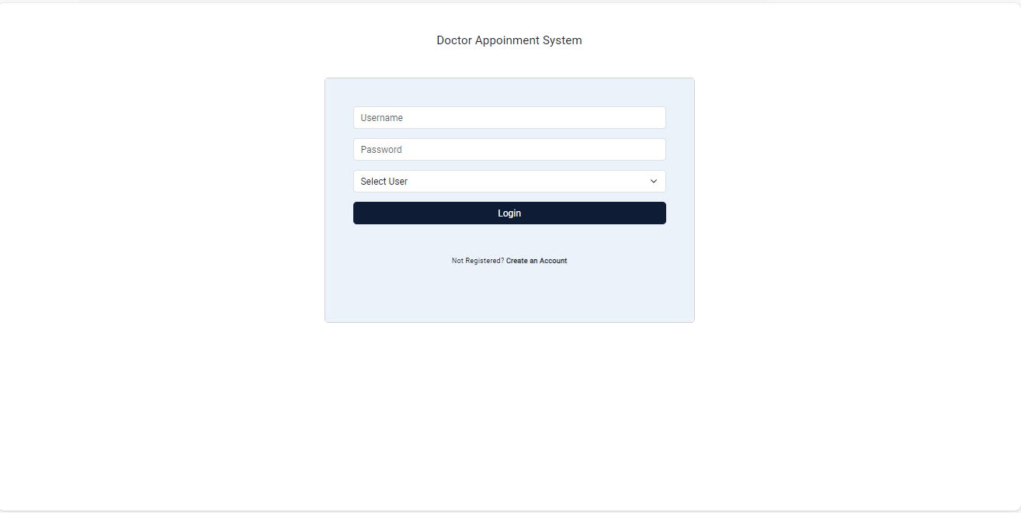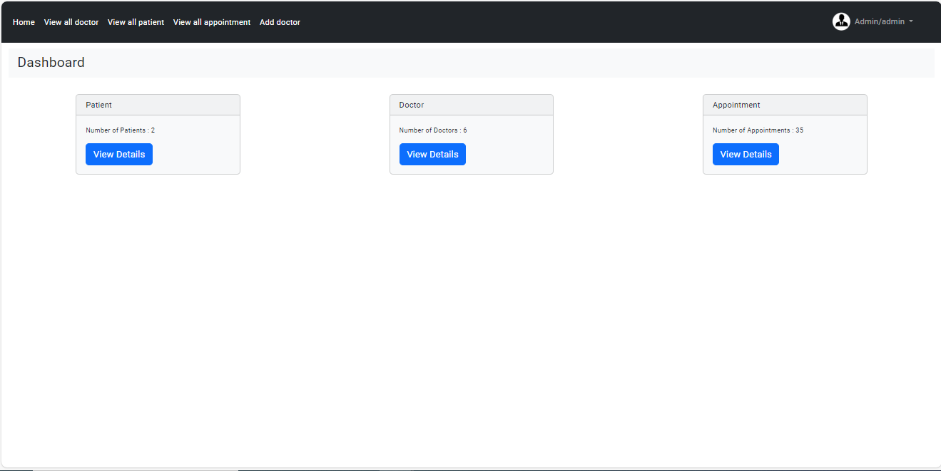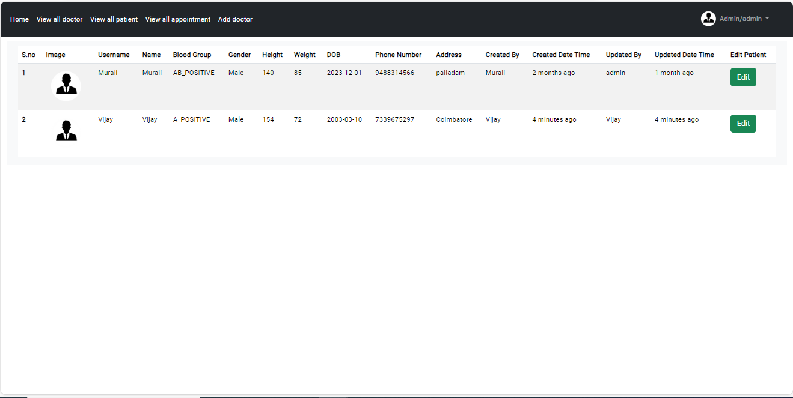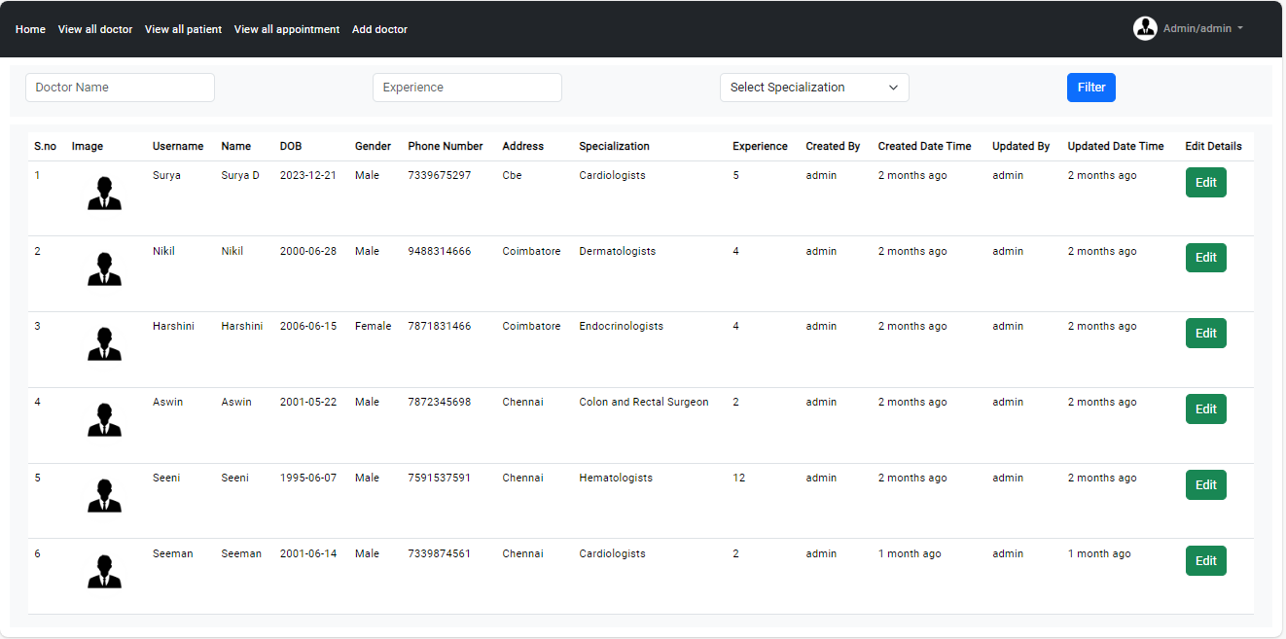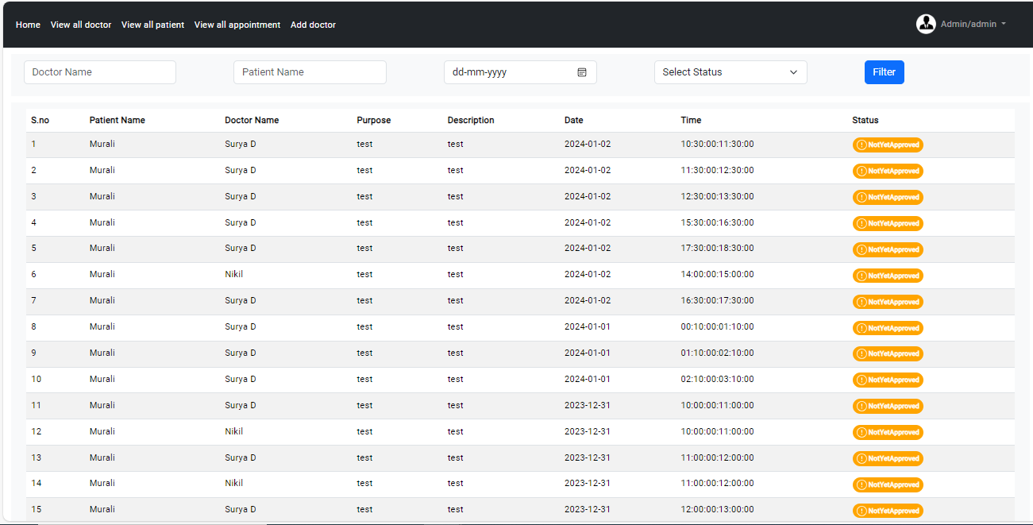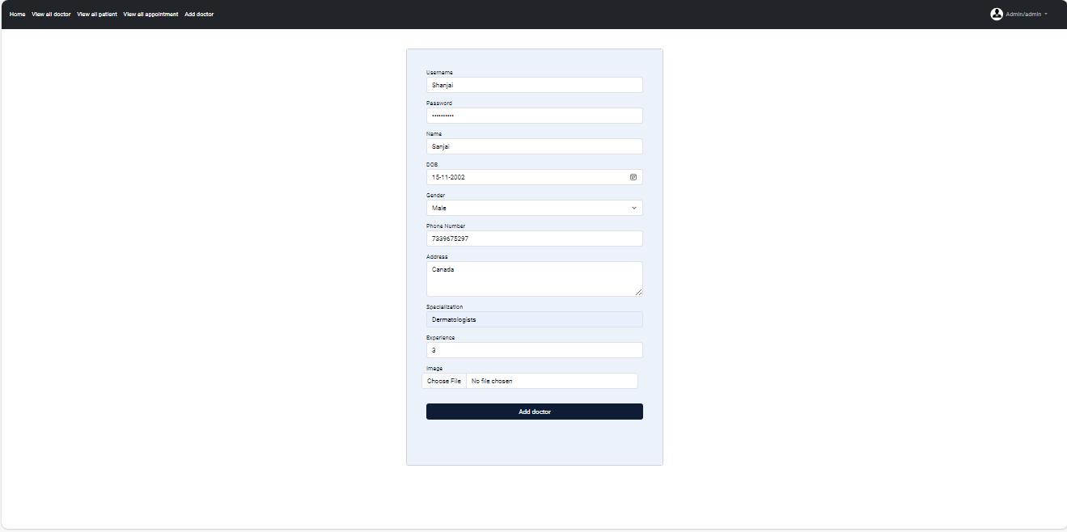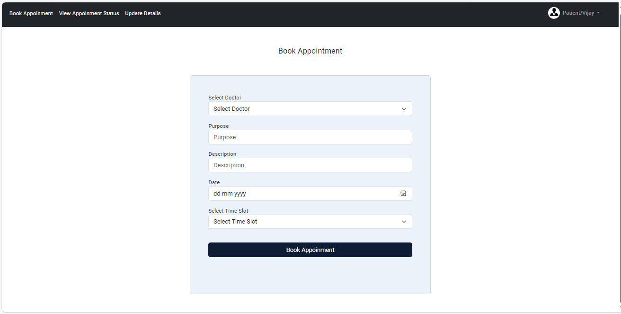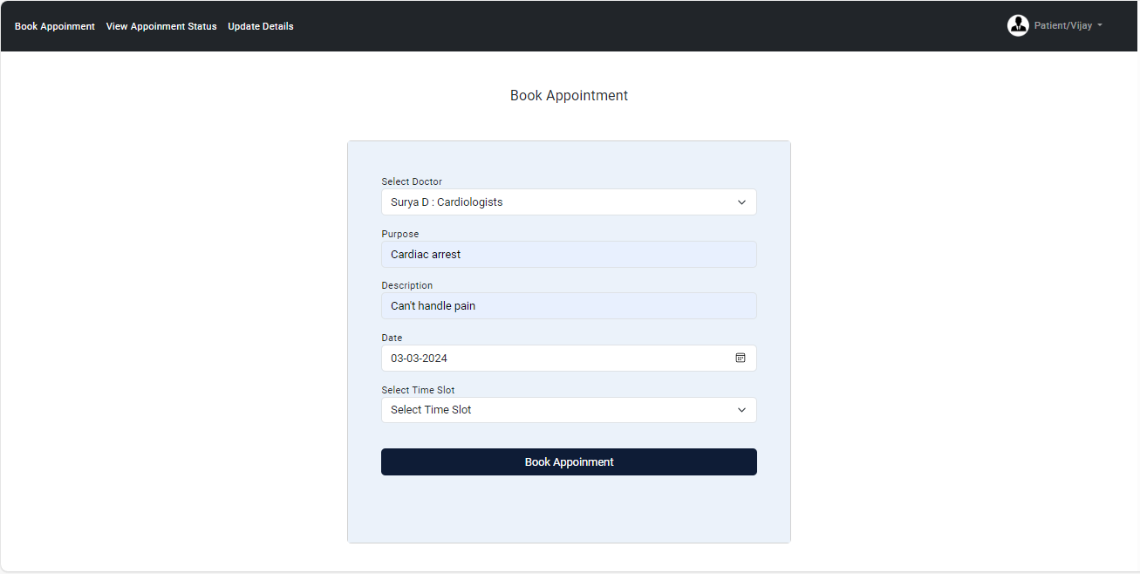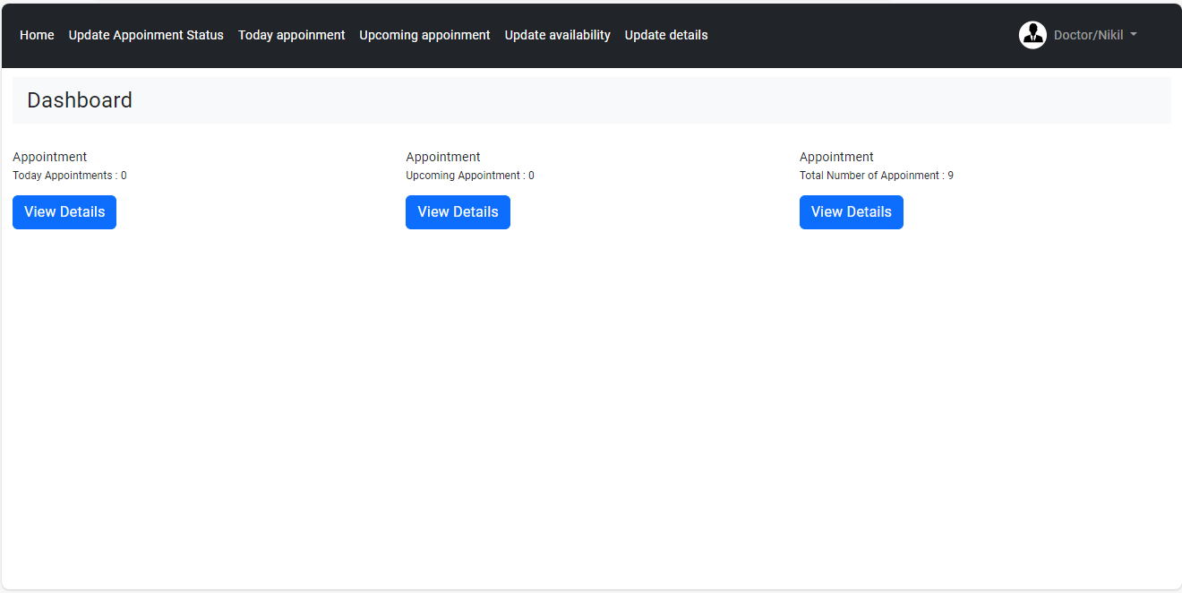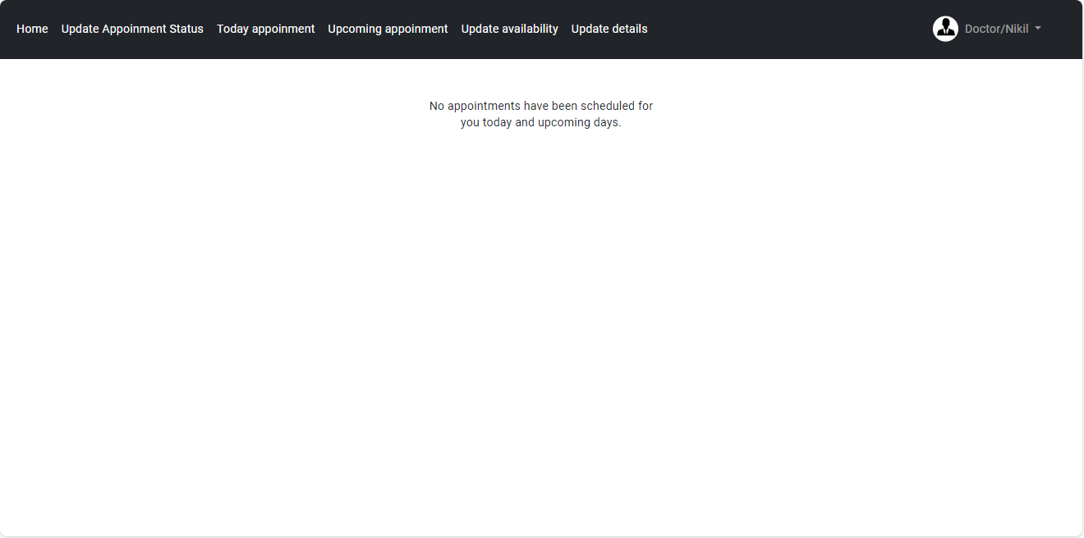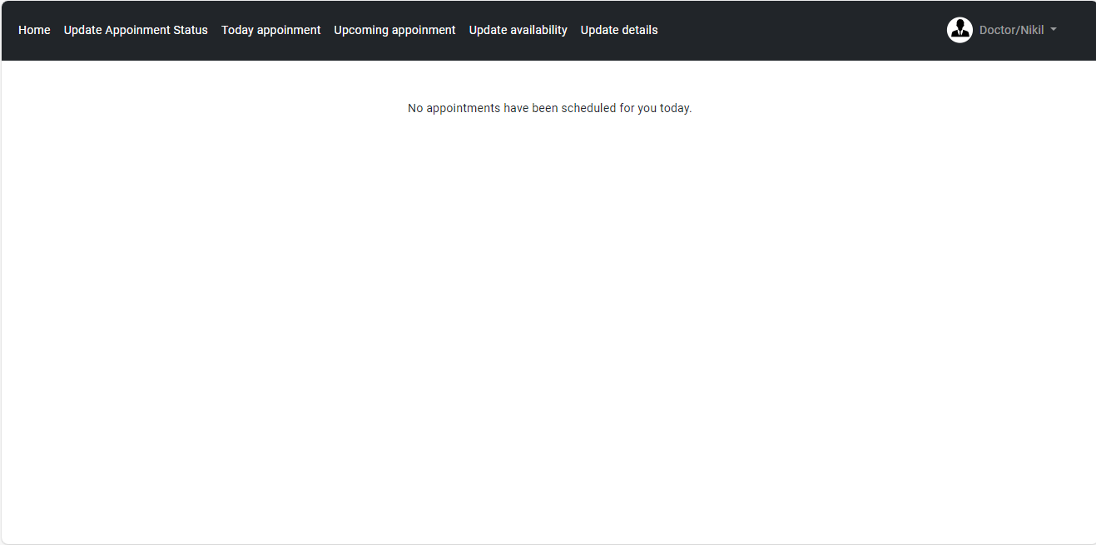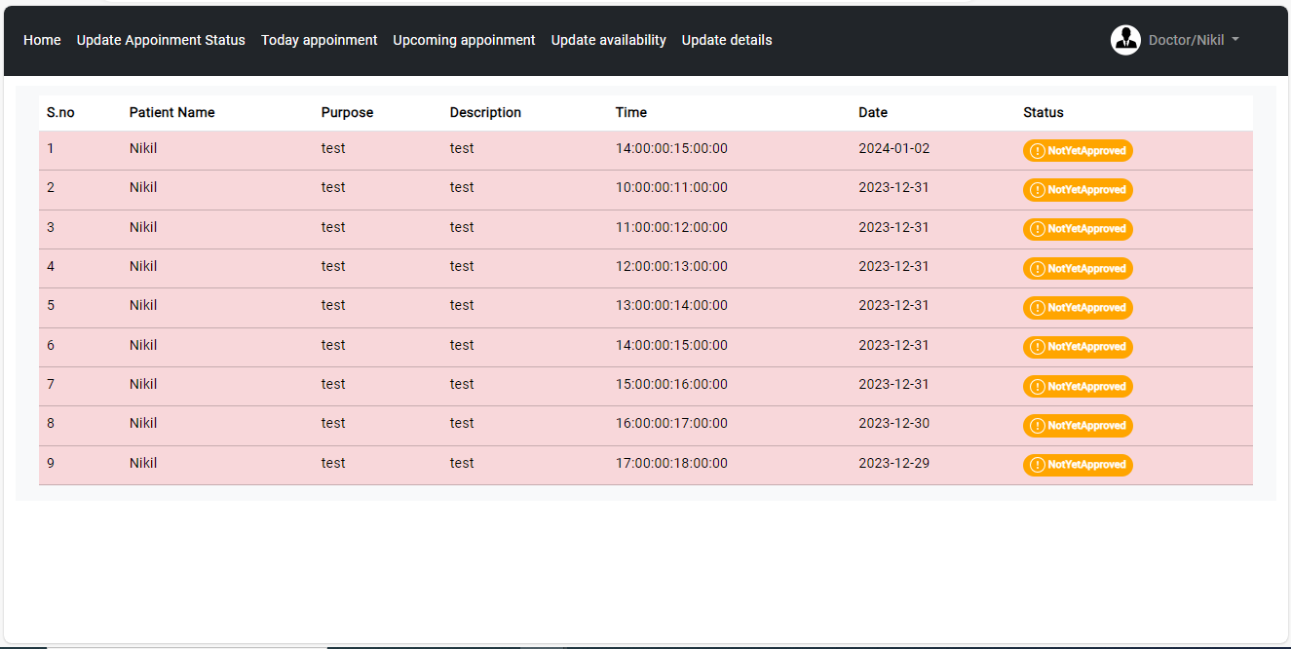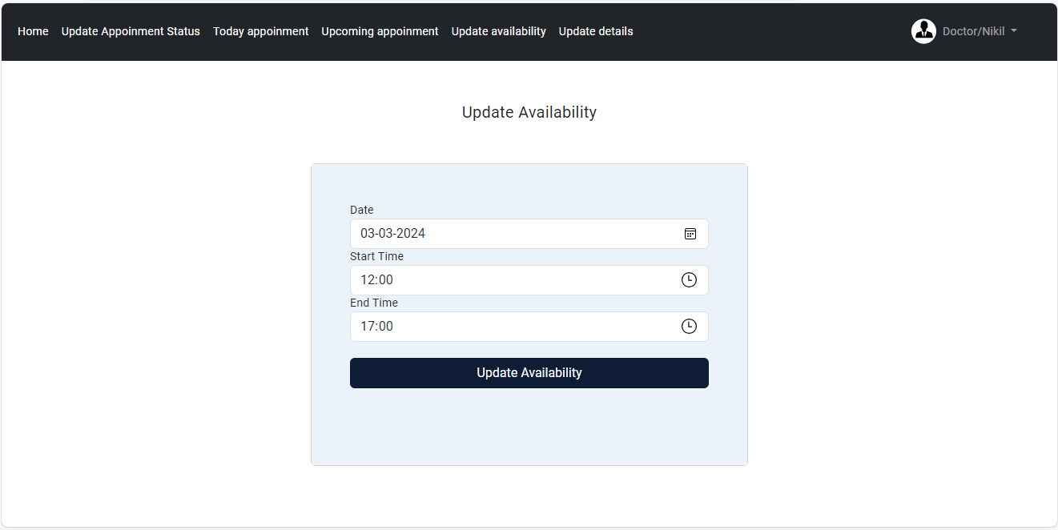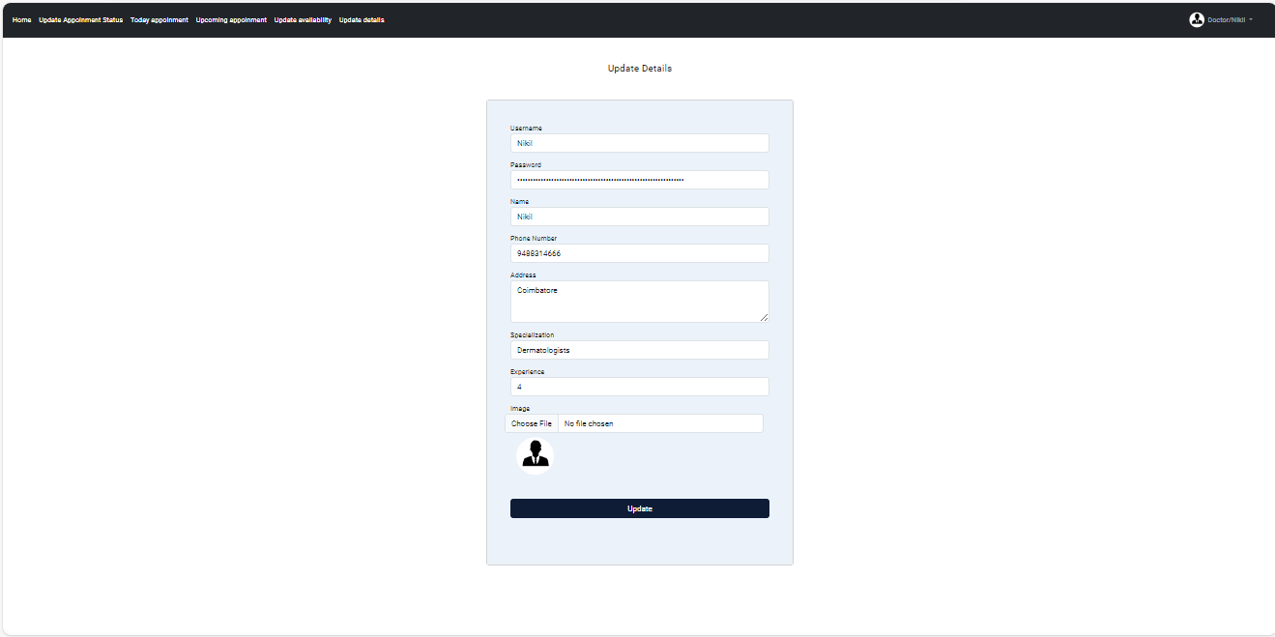

**CHAPTER - 17. FUTURE SCOPE**

The Doctor Appointment System (DAS) has already demonstrated its potential to streamline and enhance healthcare appointment management. However, its future scope for development and improvement is expansive, promising to further revolutionize the way patients access healthcare services and interact with medical providers. Here are some potential avenues for growth and enhancement in the future:

1. Expanding Service Offerings:

DAS can broaden its scope beyond appointment scheduling to offer additional services, such as telemedicine consultations, prescription refills, and medical record access. This expansion would provide patients with comprehensive healthcare management solutions through a single platform.

2. Advanced Analytics and Predictive Modeling:

Future iterations of DAS can leverage advanced analytics and predictive modeling to optimize appointment scheduling, predict patient demand, and allocate resources efficiently. Machine learning algorithms can analyze historical data to identify patterns and trends, enabling healthcare providers to proactively manage patient flow and optimize clinic operations.

3. Telehealth Integration:

Integration with telehealth platforms can enable seamless virtual appointments and consultations within DAS. Patients can schedule telehealth appointments, communicate with healthcare providers, and access telemedicine services directly through the system, enhancing convenience and accessibility.

4. Patient Engagement and Education:

DAS can incorporate features to engage and educate patients about their health conditions, treatment plans, and preventive care measures. Interactive educational resources, personalized health tips, and reminders for follow-up appointments or screenings can empower patients to take an active role in managing their health.

5. Real-Time Feedback and Quality Improvement:

Implementing real-time feedback mechanisms within DAS allows patients to provide input on their appointment experience and satisfaction levels. Healthcare providers can use this feedback to identify areas for improvement and enhance the quality of care delivery continuously.

6. Integration with Wearable Devices and Health Trackers:

Integrating DAS with wearable devices and health trackers enables patients to sync their health data directly with their appointments. Healthcare providers can access real-time patient metrics, such as heart rate, activity levels, and medication adherence, to inform clinical decision-making and personalize treatment plans.

7. Enhanced Mobile Experience:

Further optimization of DAS for mobile devices ensures seamless access and functionality for patients on-the-go. Mobile apps can offer features like appointment reminders, GPS navigation to clinic locations, and secure messaging with healthcare providers, enhancing the overall patient experience.

8. Internationalization and Multilingual Support:

To cater to a diverse patient population, DAS can offer multilingual support and adapt to international healthcare standards and regulations. Localization efforts ensure that the system is accessible and user-friendly for patients from different cultural backgrounds and language preferences.

As DAS continues to evolve and adapt to the changing landscape of healthcare, its future holds tremendous potential to improve patient access, engagement, and outcomes. By embracing innovation, collaboration with healthcare stakeholders, and a commitment to excellence in healthcare delivery, DAS is poised to shape the future of healthcare appointment management and patient care.

**CHAPTER - 8. CONCLUSION**

In the realm of healthcare, where the convergence of technology and patient care is paramount, the Doctor Appointment System (DAS) emerges as a groundbreaking solution, revolutionizing the way healthcare appointments are managed and experienced. Reflecting on the inception and evolution of this innovative platform, and considering its myriad features, benefits, and future endeavors, it becomes apparent that DAS transcends mere utility; it is a transformative tool, a catalyst for efficiency, and a beacon of healthcare accessibility.

DAS epitomizes a seamless integration of accessibility, efficiency, and patient-centricity. It empowers patients to navigate their healthcare journey with ease, providing intuitive appointment scheduling and management tools tailored to their individual needs. Through a user-friendly interface and personalized features, DAS enhances patient engagement and satisfaction, fostering a positive healthcare experience.

Healthcare providers find in DAS a reliable ally, streamlining appointment workflows and optimizing clinic operations. The platform's robust administrative tools simplify appointment scheduling, patient communication, and resource allocation, leading to enhanced practice efficiency and patient care quality.

However, DAS is not limited to its current state; it is deeply rooted in the future of healthcare innovation. Its ambitious roadmap includes expanding appointment management capabilities, leveraging artificial intelligence for predictive scheduling, integrating telemedicine functionalities for virtual consultations, and implementing patient feedback mechanisms for continuous improvement. As these advancements unfold, DAS stands poised to redefine the landscape of healthcare appointment systems, offering an ever-evolving, dynamic, and patient-centric solution.

In DAS, the future is not a distant vision; it is a canvas upon which we paint the aspirations of patients, the goals of healthcare providers, and the evolution of healthcare delivery. The journey of DAS continues, and its future beckons healthcare professionals, patients, and innovators to collaborate in reshaping the landscape of healthcare—one appointment, one consultation, and one interaction at a time.

**CHAPTER - 19. REFERENCES**

1. **American Medical Association.** (2020). "Appointment Scheduling Best Practices: A Guide for Healthcare Providers." Available at: [https://www.ama-assn.org/practice-management/sustainability/appointment-scheduling-best-practices-guide-health-care-providers](https://www.ama-assn.org/practice-management/sustainability/appointment-scheduling-best-practices-guide-health-care-providers)

2. **Center for Connected Health Policy.** (2021). "Telehealth Coverage Policies in the Time of COVID-19." Available at: [https://www.cchpca.org/resources/covid-19-telehealth-coverage-policies](https://www.cchpca.org/resources/covid-19-telehealth-coverage-policies)

3. **HealthIT.gov.** (2021). "Telehealth and Telemedicine." Available at: [https://www.healthit.gov/topic/health-it-initiatives/telemedicine-and-telehealth](https://www.healthit.gov/topic/health-it-initiatives/telemedicine-and-telehealth)

4. **Huang, X., Lin, J., & Demner-Fushman, D.** (2016). "Evaluation of PICO as a Knowledge Representation for Clinical Questions." Available at: [https://www.ncbi.nlm.nih.gov/pmc/articles/PMC4959593/](https://www.ncbi.nlm.nih.gov/pmc/articles/PMC4959593/)

5. **McKinney, J., & Murray, K.** (2019). "Implementing Patient Self-Scheduling in a Multi-Specialty Group Practice." *Journal of Ambulatory Care Management, 42*(1), 34-42.

6. **O'Connor, S., & Hussain, T.** (2020). "Understanding the Role of Telemedicine and Telehealth During the COVID-19 Pandemic." *American Journal of Emergency Medicine, 38*(8), 1508-1509.

7. **Sundararaman, L. V.** (2020). "AI in Healthcare: From Diagnosis to Treatment." *Journal of Pharmacovigilance and Drug Research, 1*(1), 1003.

8. **U.S. Department of Health & Human Services.** (2021). "Guidance on the Application of HIPAA to Telehealth." Available at: [https://www.hhs.gov/hipaa/for-professionals/special-topics/emergency-preparedness/notification-enforcement-discretion-telehealth/index.html](https://www.hhs.gov/hipaa/for-professionals/special-topics/emergency-preparedness/notification-enforcement-discretion-telehealth/index.html)

9. **World Health Organization (WHO).** (2021). "Digital Health." Available at: [https://www.who.int/health-topics/digital-health#tab=tab_1](https://www.who.int/health-topics/digital-health#tab=tab_1)

10. **Zhang, Y., Chen, Y., & Wang, Q.** (2019). "A Survey on Telemedicine Service Platforms." *Journal of Medical Systems, 43*(5), 127.

11. **Zhu, H., Wei, X., & Mei, J.** (2018). "A Review on Telemedicine in China." *Telemedicine and e-Health, 24*(5), 407-414.